LOYALIST COLLEGE IN TORONTO

Task 1: Use a template to provision an infrastructure

Task 2: Configure an Azure Load Balancer.

Task 3: Configure an Azure Application Gateway.

In this lab we’ll learn about the concepts of load balancer which includes the configuration and testing of public load balancer and application gateway.  
  
**TASK 1:**In this task we’ll create virtual network, network security group and virtual machines using a template.  
  
We are provided by the parameters and template file to create our own custom template. We uploaded those file and run the validations and created our own custom template.  
  
Note: Here few of the students faced the issue while validations is because of the VM Size which is not compatible to the azure subscription that they had. So we need to the select the size according to the availability of the size.  
  
Here the template took 3 minutes to complete the deployment.

Task 2: Configure Azure Load Balancer

Here we will implement the Azure Load Balancer in front of two virtual machines. Its configuration contains the front-end IP address to verify the connection, a backend pool and how the connection will travel the load balancer.

* Create a load balancer while switching to the load balancer page and click on the Create.

* Create load balancer based on the given instruction and click on the next

* Here we will create new frontend IP configurations where we have to create new public IP address based on the given command

* On the Backend pools similarly create backend pools.  
  Note: It took 9-10 minutes to create the IP address  
    
  A screenshot of a computer

  Description automatically generated
* After reviewing the every step, clicked on the review and create

* Once the deployment is created then configure the rules to distribute the incoming traffic. Click on go to the resources

* In the setting blade click on the load balancing rules and add the rules given in the documents

* Copy the public ip address from the frontend ip configuration blade and paste it in the browser URL to review the text present.

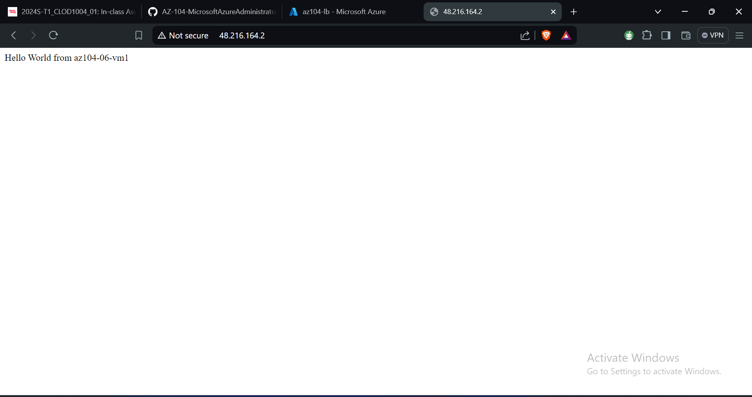

Task 3: Configure an Azure Application Gateway  
  
Here we add the azure application gateway before the Azure Virtual Machines. It provides layer7 multiple security feature like load balancing, Firewall, SSL termination and end-to-end encryption for the resources that we created in the backend pool.

* Go to the virtual network and select the mentioned virtual networks.

* Add the subnets in the selected virtual network with the given configuration.

* Go to the application gateways and create new gateway with the given configuration

* Add Backend pool

* Once rules are created then click on the review + create and create

Once the application gateway is deployed then go to the overview blade and copy the frontend public IP address. Paste the ip address in the browser URL.

Images: <http://20.51.249.18/image/>

Videos: <http://20.51.249.18/video/>

In this lab we configured the Azure Load Balancer and application gateway to manage the network traffic for the public hosted website.

The Load Balancer will distribute the incoming request from the layer 4 for the efficient utilization of resources and application gateway in layer 7 is responsible for the security.

This setup helps us to filter out the content based on the type such as images and videos. This is important to efficiently managing the resources, optimizing performances and reliability of the cloud based web application